Computational Intelligence (CI)
Computational Intelligence is a branch of Artificial Intelligence that develops intelligent systems capable of learning, adapting, and solving complex real-world problems.
It includes techniques such as: Neural Networks, Fuzzy Logic, Evolutionary Computing, Swarm Intelligence
Natural Language Processing (NLP)
Natural Language Processing (NLP) is a field of AI that enables computers to understand, process, interpret, and generate human language.
NLP combines: Artificial Intelligence, Machine Learning, Computational Linguistics
Word Embedding Techniques
Word Embedding is a method of converting text into numerical vectors so that machine learning models can understand and process language.
Word embedding converts words into mathematical representations while preserving semantic meaning.
Example:
King → [0.25, 0.78, 0.12]
Queen → [0.30, 0.82, 0.10]
Words with similar meanings have similar vector representations.
Types of Word Embedding Techniques
- Bag of Words (BoW)
- TF-IDF
- Word2Vec
- GloVe
- Neural Word Embedding
1. Bag of Words (BoW)
Bag of Words is a text representation technique that converts text into numerical vectors based on word occurrence frequency.
It ignores:
- Grammar
- Word order
- Context
Theory / Working
Step 1:
Create vocabulary from all unique words.
Step 2:
Count occurrences of each word.
Step 3:
Represent document as vector.
Example
Sentences:
I love AI
I love NLP
Vocabulary:
[I, Love, AI, NLP]
Vectors:
Sentence 1 → [1,1,1,0]
Sentence 2 → [1,1,0,1]
Advantages
- Simple implementation.
- Easy vector creation.
- Works well for small datasets.
Disadvantages
- Ignores context.
- High dimensionality.
- Does not capture semantics.
Applications
- Text classification
- Spam detection
- Document analysis
2. TF–IDF (Term Frequency – Inverse Document Frequency) - TF-IDF is a statistical technique used to measure the importance of a word in a document relative to a collection of documents.
TF-IDF gives:
- Higher weight to important words
- Lower weight to common words
Components
A. Term Frequency (TF)
Measures how often a word appears.
$$TF=\frac{\text{Word Count}}{\text{Total Words}}$$
B. Inverse Document Frequency (IDF)
Measures uniqueness.
$$IDF=log⁡\left(\frac{\text{Total Documents}}{\text{Documents containing word}}\right)$$
Formula
$$TF\text{-}IDF=TF×IDF$$
Example
Word: "Machine"
Appears frequently in one document but rarely overall.
→ High TF-IDF score
Advantages
- Highlights important words.
- Reduces effect of common words.
- Better than BoW.
Disadvantages
- Ignores word meaning.
- Cannot capture context.
Applications
- Search engines
- Information retrieval
- Text ranking
3. Word2Vec
Word2Vec is a neural-network-based word embedding technique that converts words into dense vectors while preserving semantic relationships.
Developed by: Google
Word2Vec learns word relationships from surrounding words. Words used in similar contexts obtain similar vectors.
Architectures
A. CBOW (Continuous Bag of Words)
Predicts current word from neighbouring words.
Example: I ___ AI
Predict → love
B. Skip-Gram
Predicts surrounding words from current word.
Example: love → I, AI
Example
King − Man + Woman ≈ Queen
Advantages
- Captures semantic meaning.
- Dense representation.
- Efficient for large datasets.
Disadvantages
- Requires training data.
- Context-independent.
Applications
- Recommendation systems
- NLP models
- Search systems
4. GloVe (Global Vectors)
GloVe is a word embedding technique that combines global statistical information with vector representation.
Developed by: Stanford University
GloVe learns word vectors using word co-occurrence statistics. Words appearing together frequently receive similar vectors.
Working
- Create co-occurrence matrix.
- Calculate probabilities.
- Generate vector representations.
Example
Words:
King → Queen
India → Delhi
Related words appear closer.
Advantages
- Captures global relationships.
- Efficient learning.
- Better semantic understanding.
Disadvantages
- Requires large memory.
- Static embeddings.
Applications
- NLP
- Chatbots
- Language modelling
5. Neural Word Embedding
Neural Word Embedding refers to techniques that use neural networks to generate meaningful vector representations of words.
Unlike traditional encoding methods:
- Words become dense vectors
- Similar words remain close
- Semantic relationships are preserved
Examples:
- Word2Vec
- GloVe
Working
- Text Input
- Neural Network
- Vector Learning
- Word Embedding Output
Example : Domestic Animals
Cat → [0.22,0.81]
Dog → [0.25,0.78]
Vectors are close because meanings are similar.
Advantages
- Captures context and semantics.
- Efficient learning.
- Improves NLP performance.
Disadvantages
- Computationally expensive.
- Requires large datasets.
Applications
- Machine translation
- Sentiment analysis

Compare and Contrast Word2Vec and GloVe
Word2Vec and GloVe (Global Vectors for Word Representation) are popular word embedding techniques used in NLP. Both convert words into dense numerical vectors that capture semantic relationships between words, but they differ in how embeddings are learned.
Parameter | Word2Vec | GloVe
Full Form | Word to Vector | Global Vectors for Word Representation
Developed By | Google | Stanford University
Approach | Predictive Model | Count-Based Model
Training Method | Learns by predicting surrounding words | Learns using word co-occurrence statistics
Context Usage | Uses local context window | Uses global corpus statistics
Data Representation | Neural network-based | Co-occurrence matrix-based
Computational Complexity | Faster for large datasets | Requires building co-occurrence matrix
Semantic Relationships | Captures contextual relationships well | Captures global word relationships well
Examples | CBOW, Skip-Gram | GloVe Algorithm
1. Neural Machine Translation (NMT)
Neural Machine Translation (NMT) is a deep learning-based approach used to automatically translate text from one language to another using neural networks.
Unlike traditional translation systems, NMT translates complete sentences while preserving meaning and context.
Traditional machine translation translated word-by-word or phrase-by-phrase.
Neural Machine Translation:
- Understands sentence context
- Generates natural translations
- Uses encoder–decoder architecture
Working of Neural Machine Translation
Step 1: Input sentence is provided.
Step 2: Encoder converts text into numerical representation.
Step 3: Decoder generates translated sentence.
Step 4: Output sentence is produced.
Example
Input: I love Artificial Intelligence
Output: Ich liebe künstliche Intelligenz
Advantages
- Produces natural translations.
- Captures sentence context.
- Handles long sequences.
Disadvantages
- Requires large datasets.
- Computationally expensive.
Applications
- Language translation
- Multilingual chatbots
- International communication
2. Seq2Seq (Sequence-to-Sequence) and NMT
Seq2Seq (Sequence-to-Sequence) is a neural network architecture used to convert one sequence into another sequence.It is widely used in Neural Machine Translation.
Seq2Seq converts:Input Sequence -> Output Sequence
Input and output lengths may differ.
Architecture of Seq2Seq
1. Encoder - Reads input sequence and creates context vector.
2. Context Vector - Stores learned information.
3. Decoder - Generates translated output.
Working
- Input Sentence
- Encoder
- Context Vector
- Decoder
- Translated Sentence
Example
Input: How are you
Output: Wie geht es dir
Advantages
- Supports variable length sequences.
- Handles language translation effectively.
- Learns contextual relationships.
Disadvantages
- Long sentences may reduce performance.
- Training requires large datasets.
Applications
- Translation
- Chatbots
- Text summarization
- Speech processing
3. Translation Metrics
Translation Metrics are evaluation measures used to determine translation quality. They compare machine-generated translation with reference translation.
Main metrics:
- BLEU Score
- BERT Score
A. BLEU Score (Bilingual Evaluation Understudy)
BLEU Score evaluates translation quality by comparing generated text with reference text using word overlap.
BLEU measures:
- Precision of words
- Matching phrases
- Sentence similarity
Score range:
0 → Poor Translation
1 → Perfect Translation
Formula - $BLEU=Precision×Brevity Penalty$
Example
Reference: I love AI
Generated: I love Artificial Intelligence
Higher overlap → Higher BLEU
Advantages
- Fast evaluation.
- Easy comparison.
Disadvantages
- Ignores semantic meaning.
- Sensitive to wording.
B. BERT Score
BERT Score evaluates translation quality using contextual embeddings instead of exact word matching.
Based on: BERT
BERT Score:
- Measures semantic similarity
- Understands context
- Handles synonyms
Working
Reference Sentence -> Generate Embeddings -> Compare Semantic Similarity -> Calculate Score
Example
Reference: The boy is happy
Prediction: The child is joyful
BERT Score → High
BLEU → Lower
Advantages
- Captures meaning.
- More accurate evaluation.
Disadvantages
- Computationally expensive.
Applications
- Translation evaluation
- NLP benchmarking
Traditional Metrics vs Neural Metrics for Machine Translation Evaluation
Parameter | Traditional Metrics | Neural Metrics
Evaluation Basis | Word and phrase matching | Semantic and contextual meaning
Examples | BLEU, ROUGE, METEOR | BERTScore, COMET, BLEURT
Context Understanding | Limited context understanding | Deep contextual understanding
Semantic Similarity | Poor at capturing meaning | Good at capturing meaning
Correlation with Human Judgment | Moderate | High
Computational Cost | Low | High
Accuracy | Lower | Higher
Handling Synonyms | Usually treats synonyms as different words | Recognizes similar meanings and synonyms
Implementation Complexity | Simple and easy to implement | More complex, requires neural models
5. Neural Style Transfer (NST)
Neural Style Transfer is a deep learning technique used to combine the content of one image with the artistic style of another image.
NST generates a new image by preserving:
- Content from one image
- Style from another image
Working of Neural Style Transfer (NST)
Step 1: Input Images
Two images are provided:
- Content Image → Contains objects and structure to preserve.
- Style Image → Contains artistic style, colors, and textures.
Step 2: Feature Extraction
A pre-trained CNN (e.g., VGG-19) extracts features from both images.
- Lower layers extract edges and textures.
- Higher layers extract content and objects.
Step 3: Content Representation
The network captures important content features such as shapes, objects, and layout from the content image.
Step 4: Style Representation
The network extracts style features such as colors, textures, brush strokes, and artistic patterns from the style image.
Step 5: Image Generation
A random image is initialized and gradually modified to match the content of the content image and the style of the style image.
Step 6: Loss Calculation
Two losses are computed:
- Content Loss → Difference between generated and content image.
- Style Loss → Difference between generated and style image.
Total Loss = Content Loss + Style Loss
Step 7: Optimization
The generated image is repeatedly updated to minimize total loss. The final image preserves the content of the first image and the artistic style of the second image.
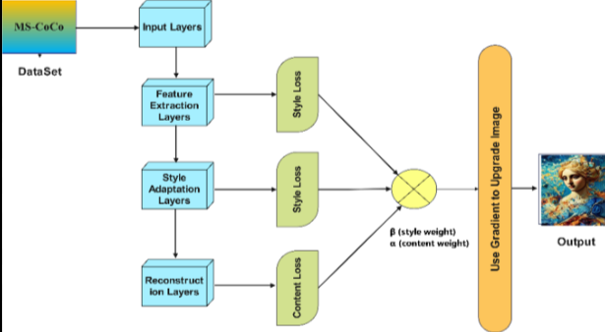
Example
Content: Photo of city
Style: Painting style
Output: City image with painting appearance.
Advantages
- Produces creative outputs.
- Preserves content and style.
Disadvantages
- Computationally expensive.
- Slow generation.
Applications
1. Digital Art
Neural Style Transfer converts ordinary images into artistic paintings using the style of famous artworks.
2. Design
It helps designers create unique visual styles for products, websites, and graphic designs.
3. Entertainment
It is used in movies, games, and animations to generate creative visual effects and artistic scenes.
4. Media Editing
It enhances photos and videos by applying different artistic styles and visual transformations.
Pretrained NLP BERT Model and Applications
BERT (Bidirectional Encoder Representations from Transformers) is a pretrained language model designed to understand text context from both directions.Developed by: Google
Significance of Pre-trained BERT Models
1. Better Context Understanding
BERT reads text in both directions, allowing it to understand the complete context of words.
2. High Accuracy
It provides better performance than traditional NLP models in many language tasks.
3. Reduced Training Time
Since BERT is already pre-trained, only fine-tuning is required for specific applications.
4. Transfer Learning
The same pre-trained model can be adapted to multiple NLP tasks.
5. Handles Ambiguous Words
BERT understands word meaning based on context, improving language understanding.
Working of BERT
1. Bidirectional Learning
BERT reads text in both directions (left-to-right and right-to-left) simultaneously. This helps it understand the complete context of a word.
2. Transformer Encoder
BERT uses only the Encoder part of the Transformer architecture to process text and learn relationships between words.
3. Pre-Training
BERT is trained on large amounts of text using two tasks:
a) Masked Language Model (MLM)
- Some words are hidden (masked).
- BERT predicts the missing words.
Example:
I love [MASK] learning.
Output:
I love machine learning.
b) Next Sentence Prediction (NSP)
- Determines whether one sentence logically follows another.
4. Fine-Tuning
After pre-training, BERT can be fine-tuned for specific tasks such as sentiment analysis, text classification, question answering, and machine translation.
Features of BERT
- Bidirectional learning
- Context awareness
- Transfer learning
- Pretrained architecture
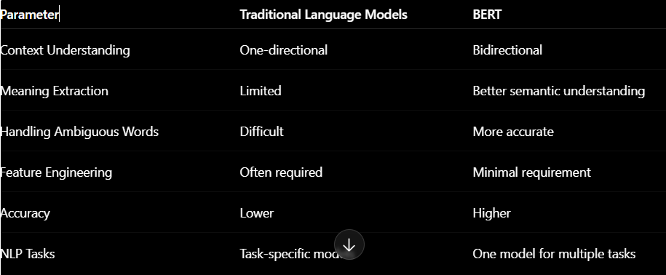
Applications of BERT
1. Question Answering
BERT can understand questions and accurately extract relevant answers from a given text.
2. Sentiment Analysis
BERT identifies the sentiment of text as positive, negative, or neutral.
3. Machine Translation
BERT helps improve translation quality by understanding the context and meaning of words.
4. Chatbots
BERT enables chatbots to understand user queries and generate more relevant responses.
5. Text Summarization
BERT helps create concise summaries while preserving the important information from a document.
6. Search Engines
BERT improves search results by understanding the intent and context of user queries.

